Installation of Apache Tomcat and Jenkins Pipeline for MyMavenWebApp01
Installation of Apache Tomcat:
Step 1: To install Apache tomcat in root folder, type the command sudo -i and then sudo apt update && sudo upgrade -y

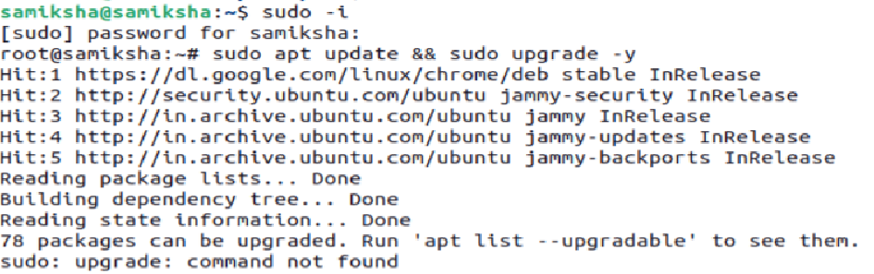
Enter tmp by typing the command cd /tmp and download Apache Tomcat software by typing the command wget https://archive.apache.org/dist/tomcat/tomcat-9/v9.0.95/bin/apache-tomcat-9.0.95.tar.gz
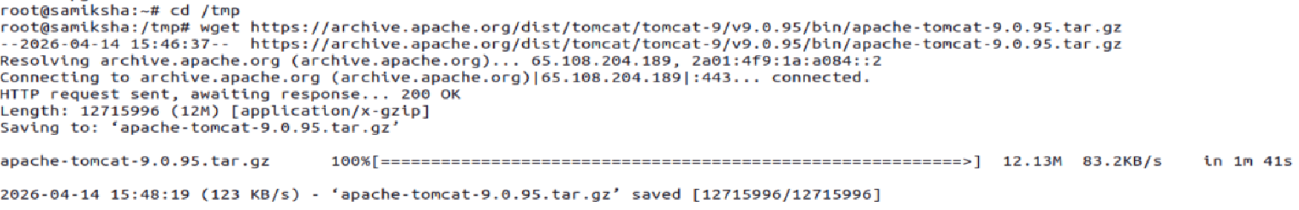
Then endter type cd .. and extract the downloaded to opt in root by typing the commands
cd opt
mkdir tomcat
cd ..
cd tmp
to extract the tar file into tomcat folder run the command sudo tar -xvzf apache-tomcat-9.0.95.tar.gz -C /opt/tomcat --strip-components=1
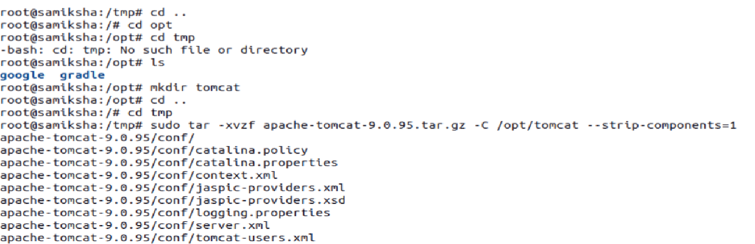

Enter tomcat and type ls to see all files are extracted
Enter conf cd conf and type ls to see server.
xml use this file to change the port number from default 8080 to any number say 9090 because Jenkins is running on 8080
Type gedit server.xml and go to line number 70 and change the portnumber to and save
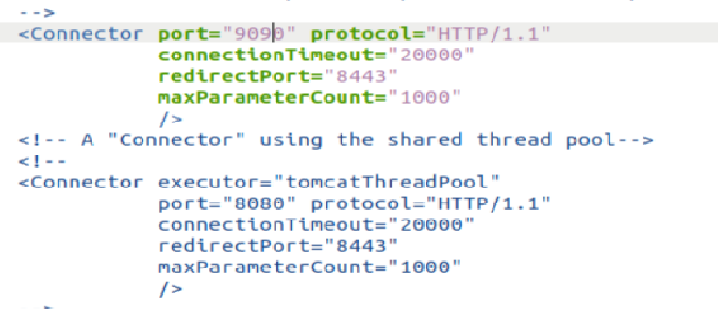
we need to create tomcat users as well so add the users in tomcat-users.xml file by typing the command gedit tomcat-users.xml
go to line 22 add the line <user username="admin" password="Admin" roles="manager-gui"/>

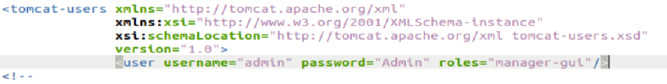
Then enter bin and type ls
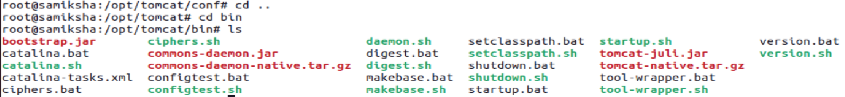

we can type the commands startup.sh and shutdown.sh to start the tomcat and stop the tomcat
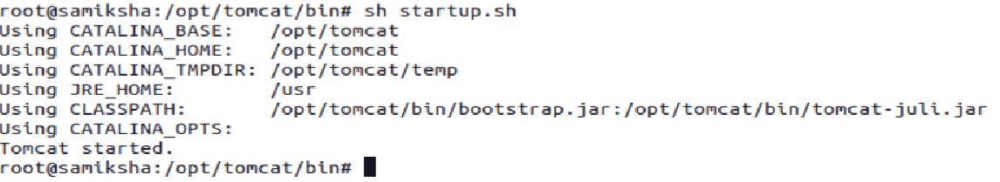
open the page in browser say localhost:9090
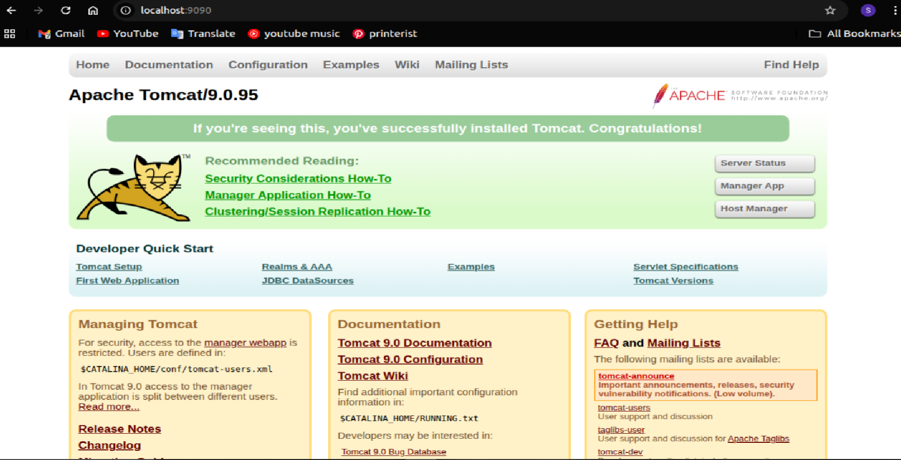
Click on Manager App enter the credentials previously provided
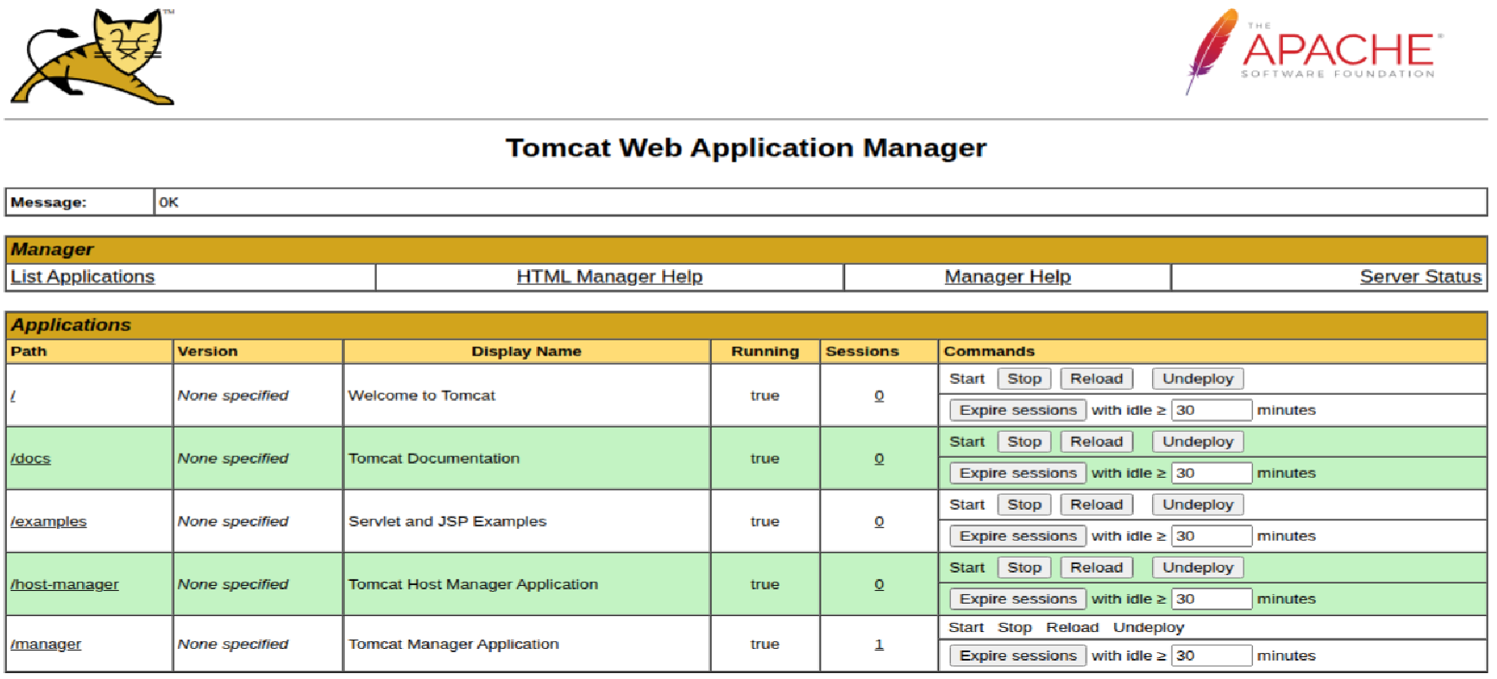

Jenkins Pipeline for MyMavenWebApp01
Step 1: open the terminal and type the command cd MyMavenWebApp01 and create a Jenkinsfile containing the pipeline code, and then commit and push it to GitHub.
pipeline {
agent any // Use any available agent

tools {
maven 'Maven' // Ensure this matches the name configured in Jenkins
}
stages {
stage('Checkout') {
steps {
git branch: 'master', url: 'https://github.com/Samiksha201104 /MyMavenWebApp01.git'
}}
stage('Build') {
steps {
sh 'mvn clean package' // Run Maven build
}}
stage('Test') {
steps {
sh 'mvn test' // Run unit tests
}}
stage('Deploy WAR') {
steps {
sh 'cp target/MymavenWebApp01.war /opt/tomcat/webapps/'
}}}
post {
success {
echo 'Build and deployment successful!'
}
failure {
echo 'Build failed!'
}}}
Go to index.jsp file and edit the hello wold code and paste the following code
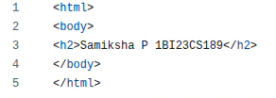
Step 2: Go to Jenkis Dashboard click on new item enter the item name as MyMavenWebApp and select pipeline. In the configure select pipeline scm paste the repository url select github credentials applyand save
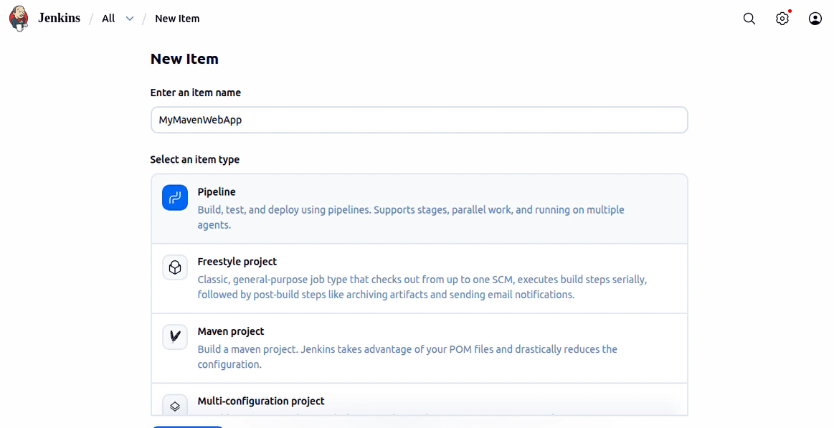

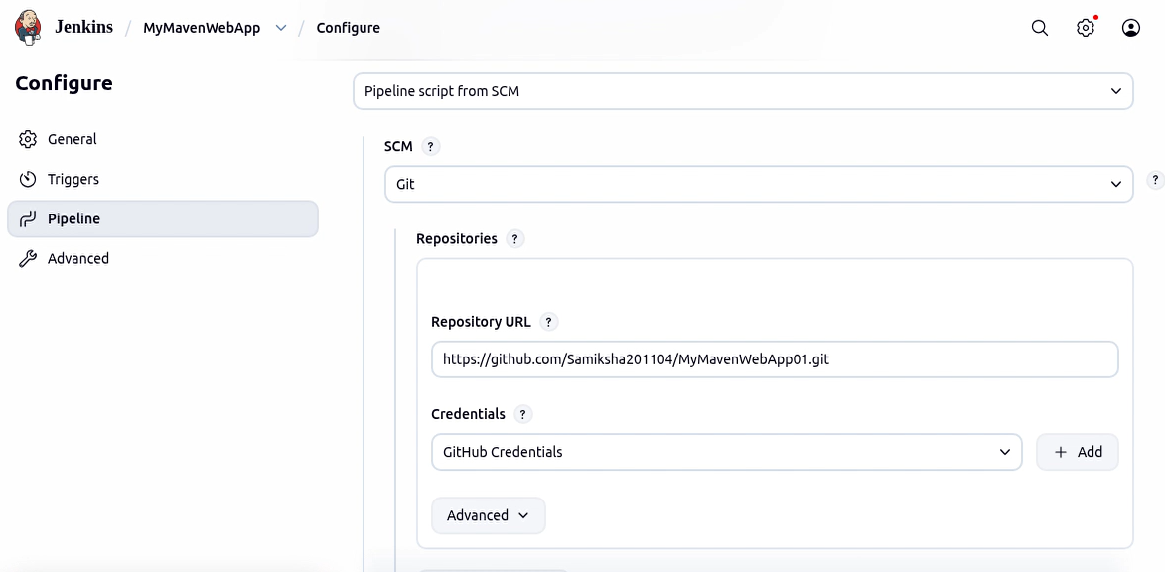

Step 3: go MyMavenWebApp in Jenkins and click Build Now; the build completes successfully.
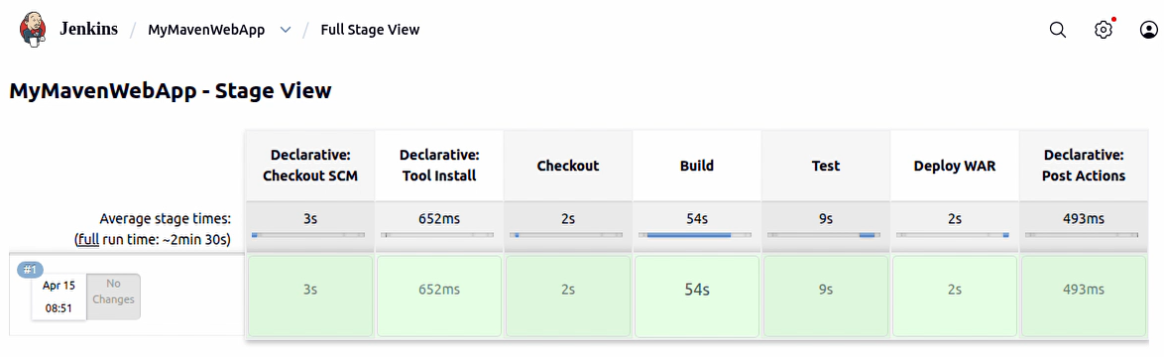
Step 4: go to Tomcat Web Application Manager and select the path /MyMavenWebApp01
